**Kick Starter Goal Conversion by Amount and Month**

In this exercise, we reviewed at the request of our client, Louise, using Kick-Starter data to analyze KPIs (key performance indicators) forcategories associated to ‘Theater’ and ‘plays’ based on amount by goal and by conversion outcome. By reviewing the data collected from Kickstarter, the client will be able to utilize this information to find ways to ensure that her Kick-Starter campaign has the best chance of being successful as well as to determine best ways to achieve goal as well as highlight risks to make a better informed decision using the data provided.

In order to search for success and conversion KPIs by category, ‘Theater’ and ‘plays’, data from 2009 – 2017 kickstarter launches were reviewed and analyzed so that the client had a vast amount of data to identify any outliers and to use the quantity of data to normalize as needed. The objective was to identify outcome criteria category ‘theater’ and subcategory ‘plays’ by kick starter launch date. To do so, a pivot table was created to group raw data by month to outcome criterias ‘successful’, ‘failed’, and ‘cancelled’ outcomes (see figure 1-3 below).

**Figure 1**



**Figure 2**



**Figure 3**

From the trends, kick starters parent category ‘Theater’ had the most success when launched in the month of May not just from the number of successful outcomes, but also based on percentage by weight with 66.87% success, 31.33% failed, and 1.81% cancelled. Compared to other months to launch, the data provided consistent results with the highest chance of success and the best opportunity to avoid any adverse outcomes.

Knowing that the client wanted to pursue to success for the project related to ‘plays’, the data was researched further into the sublayer to tie success based on the play subcategory in relation to goal thresholds. Since 2009 – 2017, we identified that no kickstarter tied to subcategory were ever cancelled which was a good sign for the client (Figure 4). Further outcomes were dug in based on ‘successful’ and ‘failed’ criteria to further identify stability and likelihood of achieving goal based on initiative. Upon further investigation, kickstarter for ‘plays’ had the highest percentage chance of being successful if the goal amount was within the “Less than $1000” threshold with 75.81% success and 24.19% failed. The success rate dropped gradually as goal amount thresholds increased in increments of $5000, reaching a 50% success rate within the threshold of “15,000 to $19,999”. Numbers gradually dropped until it stabilized in success percentages reaching 66.67% within thresholds $35,000 to $44,999. Due to the small sample set of 9 kickstarters that are tied to this goal threshold, we advise the client, Louise, to take this threshold with caution as this particular threshold only accounts to 0.85% of total volume and would be a risky move to aim this high. Analysis were further visualized using a line graph to find trends where the success criteria overtook the failed criteria, and made notes of importance as to when the failed line overtook in prominence to serve as risk factors starting in the $15,000 to $19,999 threshold (Figure 5).



**Figure 4**

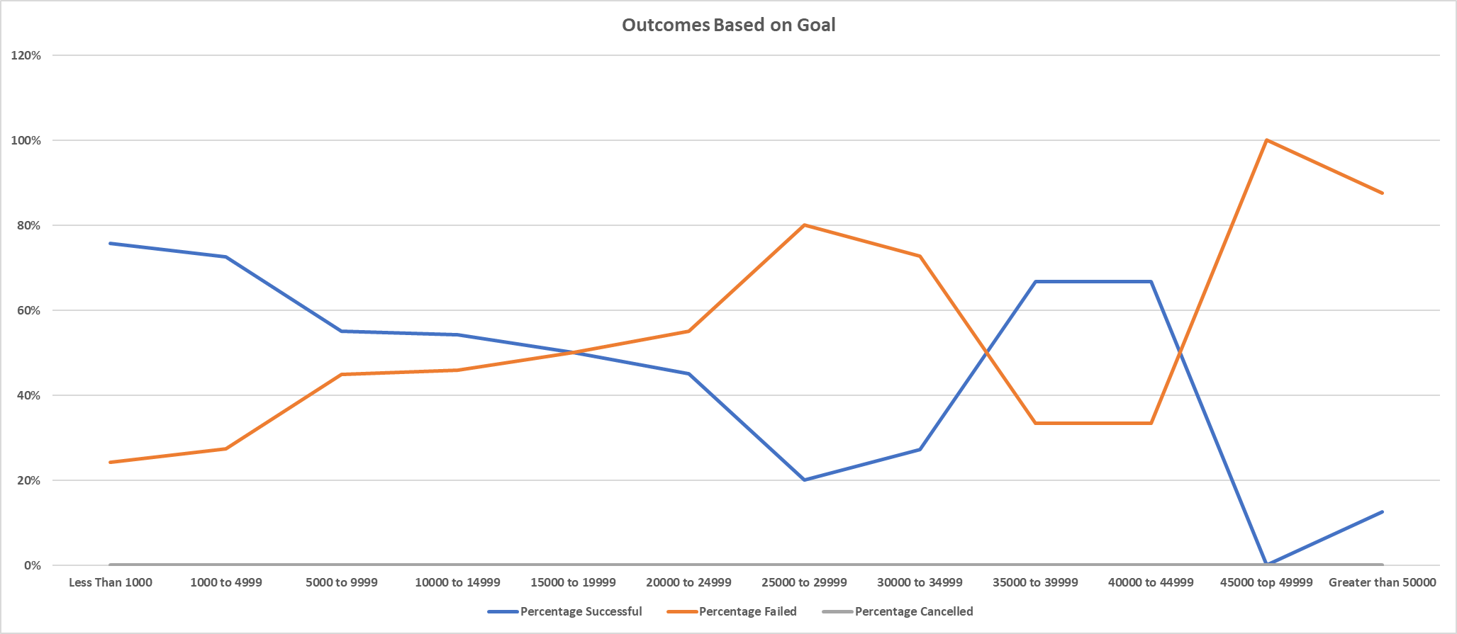

**Figure 5**

In conclusion, the client has the best chance of success by implementing the kick-starter program in May with a budget threshold not to exceed $19,999 to ensure that she has the most opportunities of success based on kick-starters historical trends over the last 8 years. Plays, over the last 8 years, have a 66.28% of being successful across all campaign monetary thresholds, so assuming that the client keeps in mind month and thresholds, she has a good chance of reaching her goal to fund Fever, the next greatest sensation to hit broadway streets and local venues.